Word Wizard
“Non-verbal individuals often rely on communication tools that are very limited and difficult to customize, as users often have different needs. Educators would benefit from a device that converts physical input to verbal communication that is portable and customizable.”

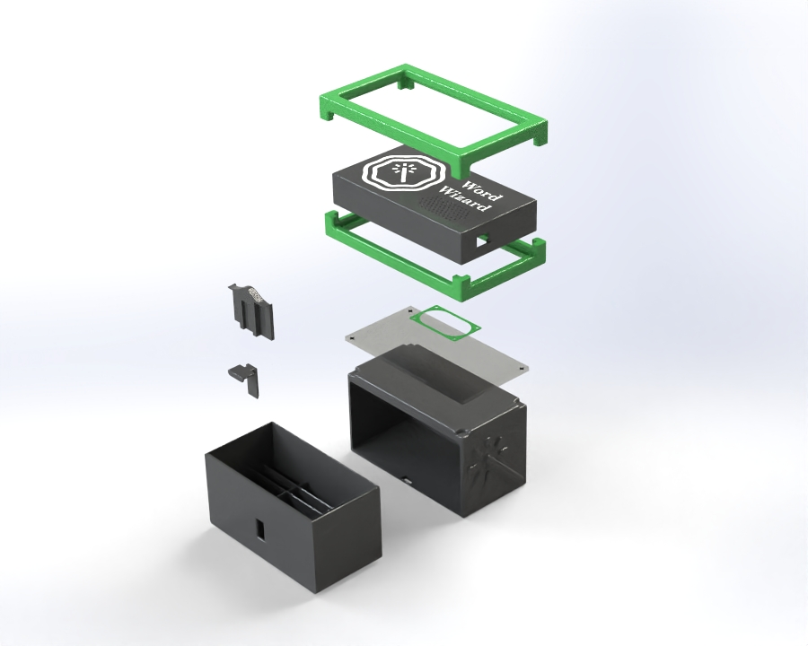
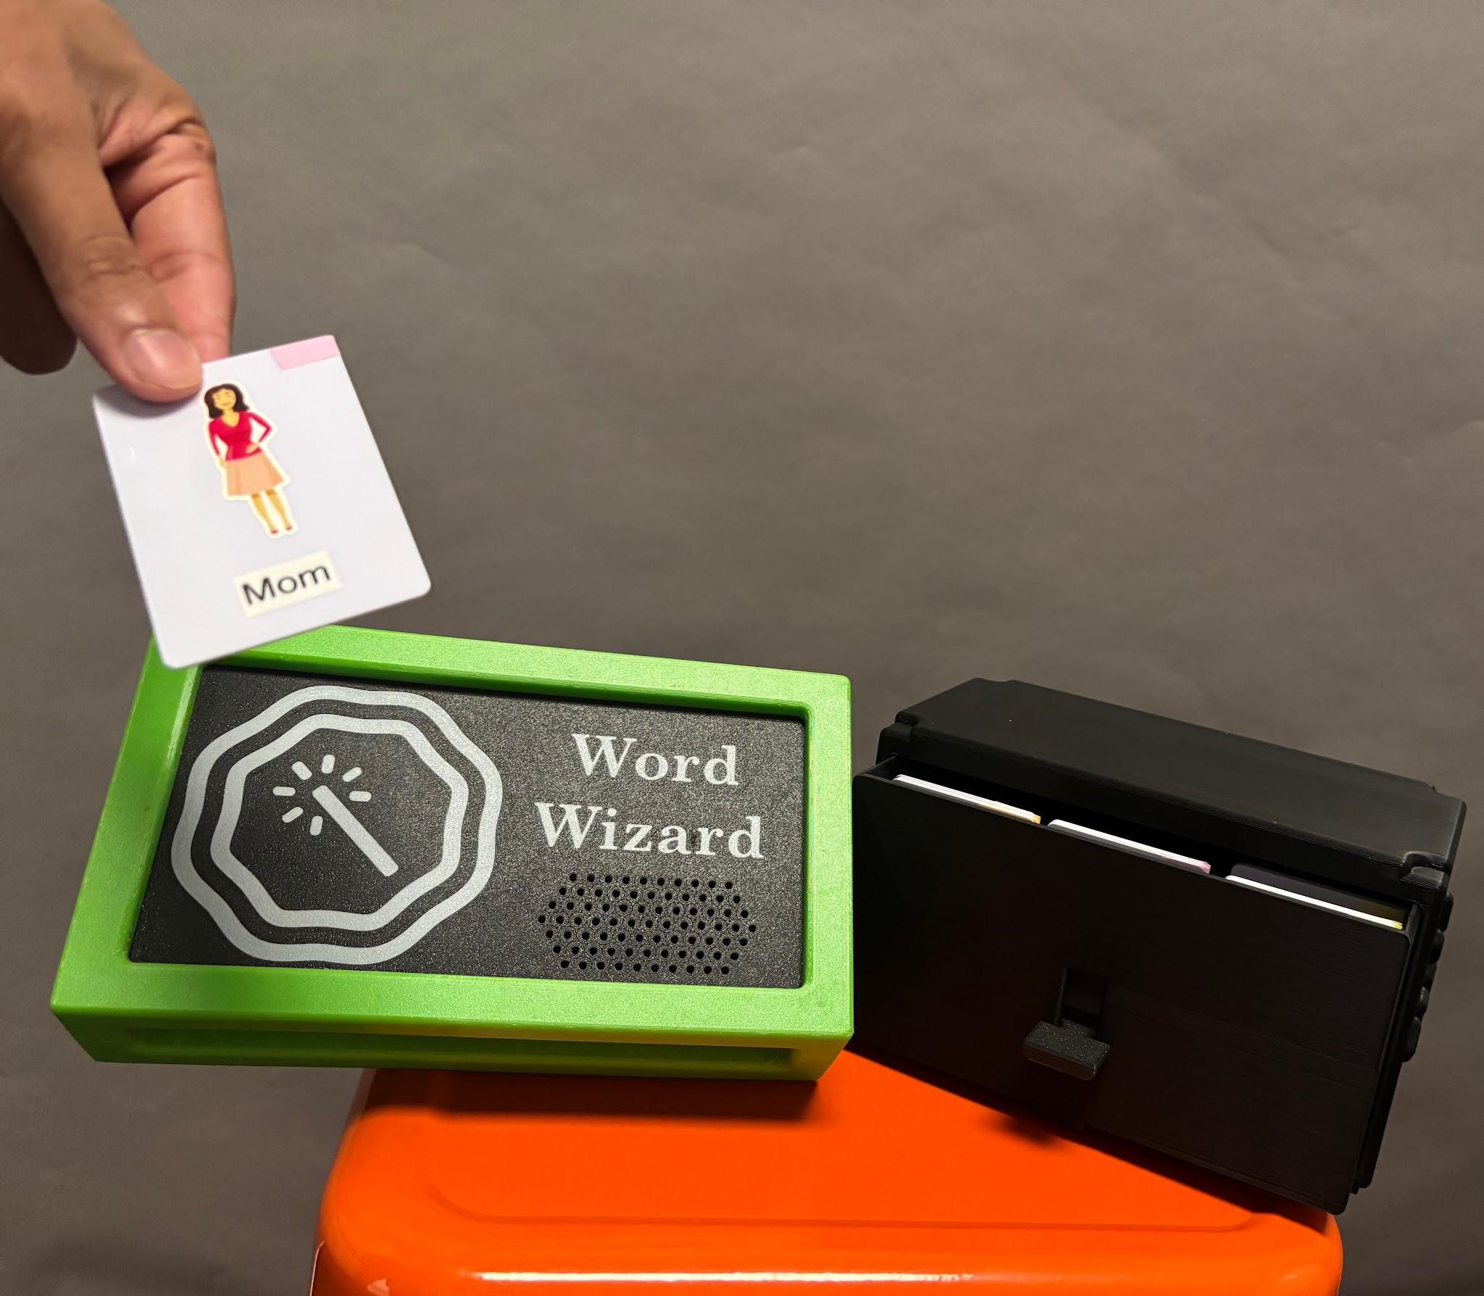
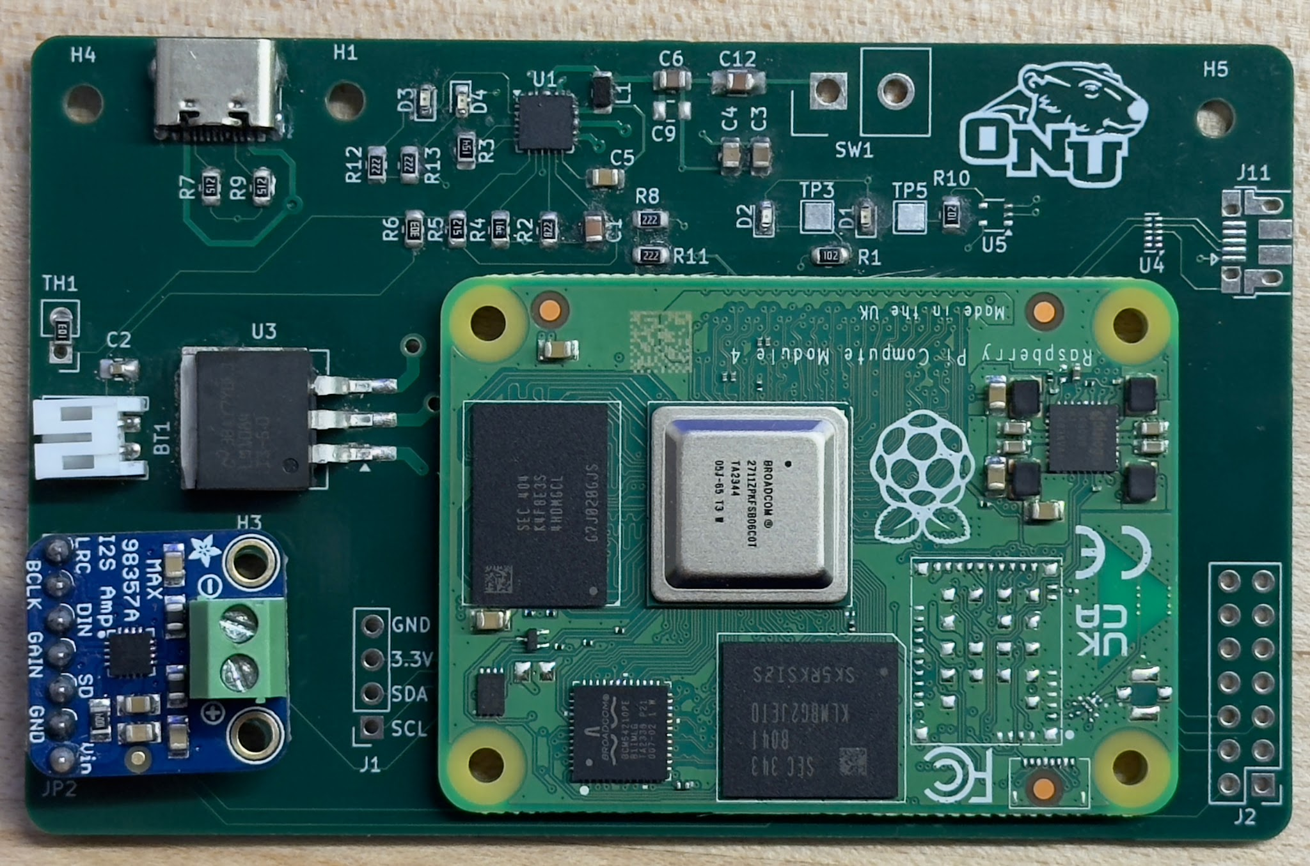
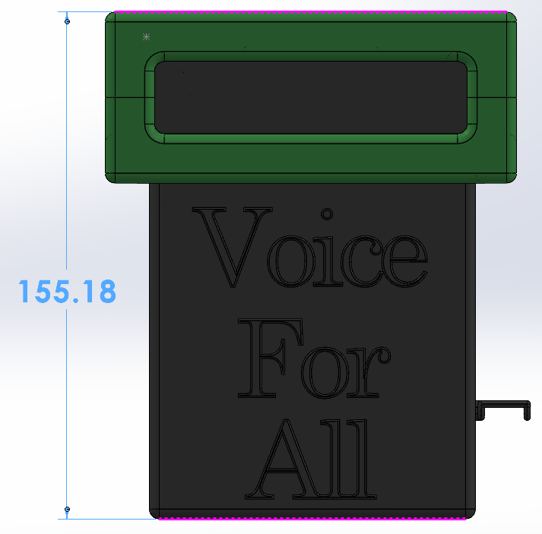
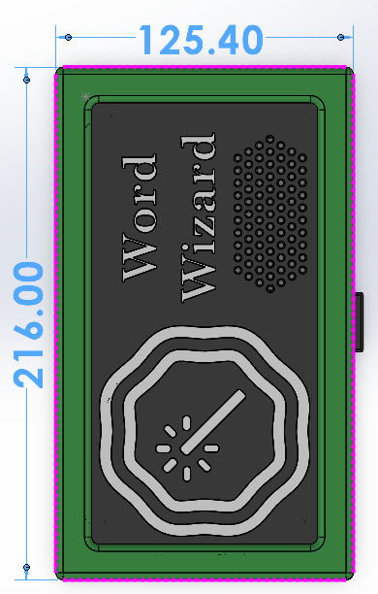
Figure 1: CAD Assembly of Device
Figure 5: Electronics
Figure 2: Demonstration of use of device
Figure 4: Dimensions of device from above
(mm)
Figure 3: Dimensions of device from
side (mm)

Next Steps
While this design was extensively researched and revised over the course of the semester, our team recognized several features that could still be improved given we had more time. While our current storage system is innovative and easy to navigate, we believe the system could be improved by making the cards accessible from the top of the box rather than a drawer system to lower the complexity of operating the system for our primary stakeholder, the user. We also presume that making the device and the card system one piece would improve the manageability of Word Wizard for teachers and parents. Additionally we hope that in the future the bumper could be injection molded silicone so that we are not limited to 3-D printing capabilities. This is so we can make the bumper removable, similar to a phone case to improve the cleanability of the device. Finally we would implement an SPI communication protocol rather than the I2S protocol we currently use to optimize software speed for the device. These changes would help us compete in the global market more effectively and provide the best overall product for all stakeholders.
There are many ecodesign strategies we could employ in the further development of our product. We could optimize the end of life system by making all the hardware components accessible by common screws. This is so that we can increase the ease of disassembly and recyclability of the various different components. While this will be good for properly recycling components at end of life, it could tempt users to tinker and harm device functionality. Additionally we could optimize the initial lifetime by reducing the amount of soldered parts to connectors. While this makes repairability easier it could harm the reliability of the product as parts could be jostled loose during use. This is so that electronic parts can be easily swapped out to increase the lifespan of the device. Lastly we could further the reduction of materials by finding ways to further consolidate the footprint of the electronics. This will allow us to shrink the size of the device, reducing the necessary material required to fabricate all related parts. While this could reduce the footprint of the electronics, it could increase the complexity of the electronics further driving up costs. While these ecodesign strategies have pros and cons, we believe that there is a middle ground that makes these aspirations viable.

Broader Impacts
Table 1: Broader Impacts
 | Benefit | Risks and Tradeoffs
People - Public Health, Safety & Welfare | - Utilizing a shock absorbent TPU bumper reduces injury risk when dropped or thrown  - USB - C eliminates the need for proprietary application specific cables  - Simple NFC tap input reduces cognitive load for the intended user | - Easy to access screws for easy repair can be a a safety hazard to young and curious individuals  - TPU bumper increases overall footprint of device  - Drawer system requires device to have two separate parts to manage
People - Global / Cultural Factors | - Color coded Fitzgerald Key is a widely recognized AAC standard  - utilizing Piper TTS model allows the system to output multiple languages and dialects | - color coding may not transfer across different cultures  - NFC programming requires a smartphone or other proprietary device
Planet - Environmental | - programmable reduces need for laminate and print waste  - Modular electronic hardware allows for extended life of device, reducing waste  - Rechargeable battery reduces single-use waste  - ABS and TPU are recyclable materials | - Various electrical components like the PCB are non-biodegradable  - Current manufacturing process is very energy intensive
Profit - Economic | - Lower cost than tablet alternative AAC’s  - Design is easily scalable and modular to accommodate large quantity needs for schools or care centers  - Electronics are easy to fabricate and price gets lower as the bulk of the order increases | - a switch to SPI protocol would require further man-hours driving up our R&D costs  - Our product has a long lifespan which will reduce our repeat business unless we come out with an updated more enticing product.

Appendix 1: Problem Framing
Overview: Problem Framing Documentation For FoD2 Semester Project ‘Word Wizard’

Broader Impacts:
- People - Inclusion and Accessibility to reduce stigma around disability
- Planet - Long-lasting and purpose built solution allows for less material waste and power consumption
- Profit - Lower cost and scalable solution compared to existing assistive technologies

Stakeholders:

Table 2: Stakeholders
 | Stakeholder | Impact | Design decision considerations
1 | Student | Usability, Comfort, Reliability | Safer casing, minimal simplistic inputs
2 | Teachers | Integration and Manageability | Small, rechargeable, minimal design, with clear colors for locatability
3 | Administrators | Budget and Policy Compliance | Low-tech design, Cost less than common alternatives (Tablet, or other repurposed smart device)
4 | Parents | Independence and Safety | Soft outer casing, simplistic usability for a wide age range

Research:

Table 3: Preliminary Research
 | Prompting Question | Source | Specific information gathered | What will you do with this info?
DR1
1 | How tall are classroom desks and tables? | [1] | 24”-30” | This data will influence our durability benchmarks.
2 | How can we smooth 3D prints? | [2, 3] | ABS can be smoothed with acetone, TPU can be smoothed with DMSO | Consider solvent smoothing for the surface finish of 3D printed parts
3 | What is the most common consumer charging cable? | [4] | USB Type-C is “Common on modern laptops, smartphones, and game consoles. [It] is the new industry standard.” | We will use a USB-C port for power input
4 | What kind of 3D printing filament is the most durable? | [5] | ABS has a higher impact resistance than both PLA and PETG but it has worse printability. | ABS will be the preferred filament as it is the strongest and we will have to be more careful when printing with it.
5 | Why use NFC tags instead of anything else for Voice recording? | [6] | NFC tags offer an easy, touch-based way to play, record, or update audio, making them highly accessible for tasks like labeling objects for the visually impaired or creating personalized voice messages without using complex menus. | We will use NFC tags for easy use and easy updating
6 | What are the issues with paper communication cards? | Christina Teevan, Ashland Special Needs Ministry Executive Director | The commonly used paper cards are not durable, difficult to organize, and take concentration by both parties to communicate. | We will make a device to combine physical communication cards and text-to-speech communication devices.
DR2
1 | What is an effective dB level for sufficient communication and how will our enclosure affect that? | [1] | - Target output at listener: 60-65 dB  - Upper practical range: 65-70 dB (if classroom noise is higher)  This aligns with:  - Normal speech = 60 dB  - Slightly raised voice = 65–70 dB | Aim for a noise range between 60 -65 Decibels
2 | How do educators currently store, organize, and manage communication cards in classroom environments? | [2] | Bins and Binder Pockets - Educators typically use baseball card organizers to track specific cards, and store larger amounts of cards in small storage bins | Develop a system that blends these two tracking systems. I.e. organized drawer
DR 3
1 | How can we reduce rattling of the speaker when mounted in the casing? | [1] | “When a speaker is mounted behind a cover, the sealing between the speaker and the surface dictate the Sound Pressure Level”[1]  Air leaking out the speakers rim | Add a sort of gasket to seal the speaker
2 | How can we further make cards easier to organize? | [2] | - Augmentative and Alternative Communication(AAC) systems [2]  - Fitzgerald Key: Assigns colors to differentiate various grammatical categories [2]  - Color coded designs require less cognitive load [3] | Color code the cards to better organize and track them

Assumptions:
- Because classroom desks and tables are typically 24”-30” tall [1], we assume accidental drops from approximately 3 feet onto hard flooring are likely. Therefore, we will design the enclosure to withstand at least a 3 foot drop without functional failure.
- Because some non-verbal individuals may also experience visual processing challenges, we assume high-contrast visual cues will improve usability. Therefore, we will use contrasting colors and clear iconography to indicate interaction zones.
- Based on classroom environments where many interactable objects are used simultaneously, we assume communication cards may frequently be misplaced. Therefore, we will research and integrate a dedicated card storage or tethering solution.
- Based on hygiene practices in schools and therapy settings, we assume the device will require frequent surface cleaning. Therefore, we will select enclosure materials (ABS/TPU/PLA) that tolerate repeated wiping without degradation. It also may be necessary to seal surface pores to decrease bacterial buildup.
- Because USB-C charging cables are commonly included with consumer electronics [4] and are easily purchasable, we assume that the users will have access to these cables more readily than other types. Therefore, we will include a USB-C port for power input.

Design Specifications:
Table 4: Evaluation Metric
 | Evaluation Metric | Qty. to Measure | Units | Objective | Prototype Result
1 | Battery Life | Both | Watt-Hour (Wh) | ≥ 30 Watt-hours | Utilize a rechargeable battery that still accounts for safety
2 | Boot Time | EM | Seconds (s) | minimize | Optimize hardware utilizing a compute module
3 | Response Time | EM | Seconds (s) | minimize | Optimize hardware utilizing a compute module
4 | Sound Level | EM | Decibels (dB) | ≥ 60 | Functionally test different speaker grills for housing.
5 | Portability | EM | grams(g) | minimize | Minimized unnecessary additional cables and hardware to make device as transportable as possible
6. | Variability of Word List | C | # of cards | ≥ 30 | Diversified vocabulary so device can be versatile in many scenarios
7. | Customizability of Word List | EM | # of ways to change each card | maximize | Cards can be changed on a need to need basis very easily through a simple smartphone

Appendix 2: Test Results
Test Title: Decibel Output Testing for Variable Speaker Holes

Purpose: To determine the best speaker cover to ensure the optimal sound clarity and quality determined by decibel levels.

Equipment:
- Speaker
- Microcontroller
- Amplifier
- Speaker covers (6 covers)
- Sound Level Meter
- Tape Measure
- Means to record data

Variables:
Independent Variables
Speaker Hole Size

Control Variables
Distance Between Reader and Speaker
Speaker Volume
Speaker
Material of cover
Same Word
Dependent Variables
Sound Output Level(dB)

Uncontrollable Variables
Cleanliness of speaker holes
Accuracy of measurement tools

Experimental Setup:
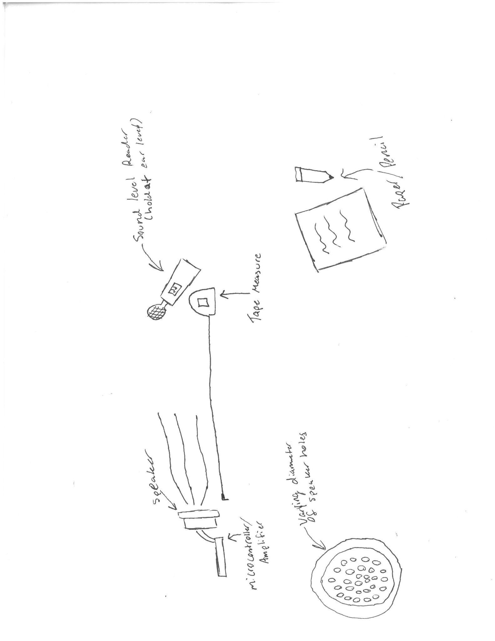
Figure 6: Setup to test audio loss due to diameter of holes

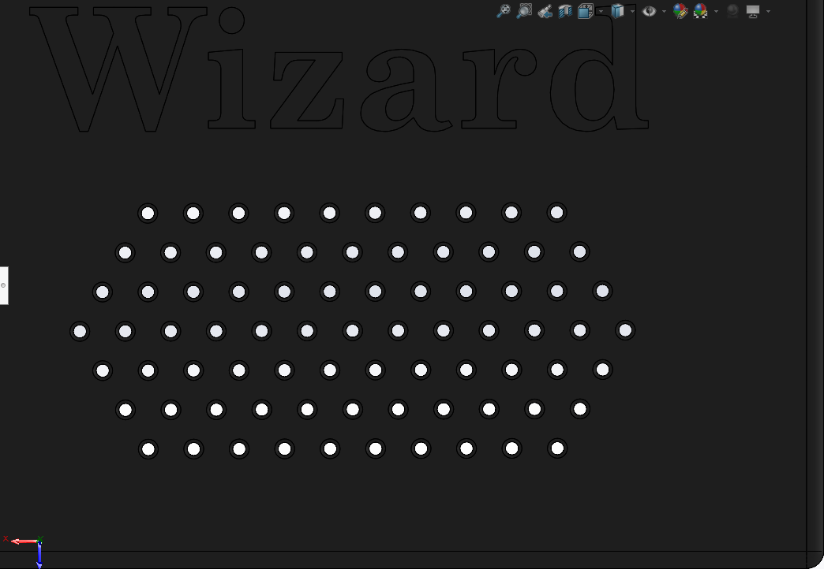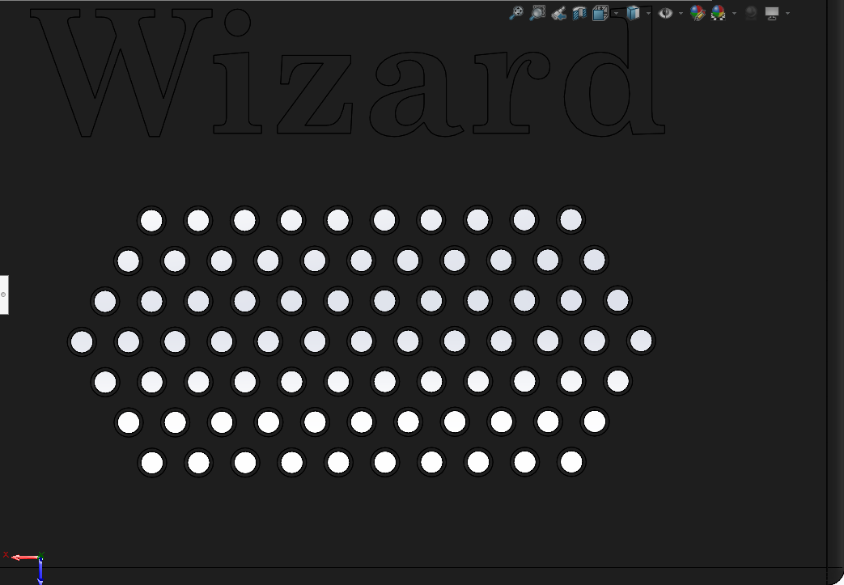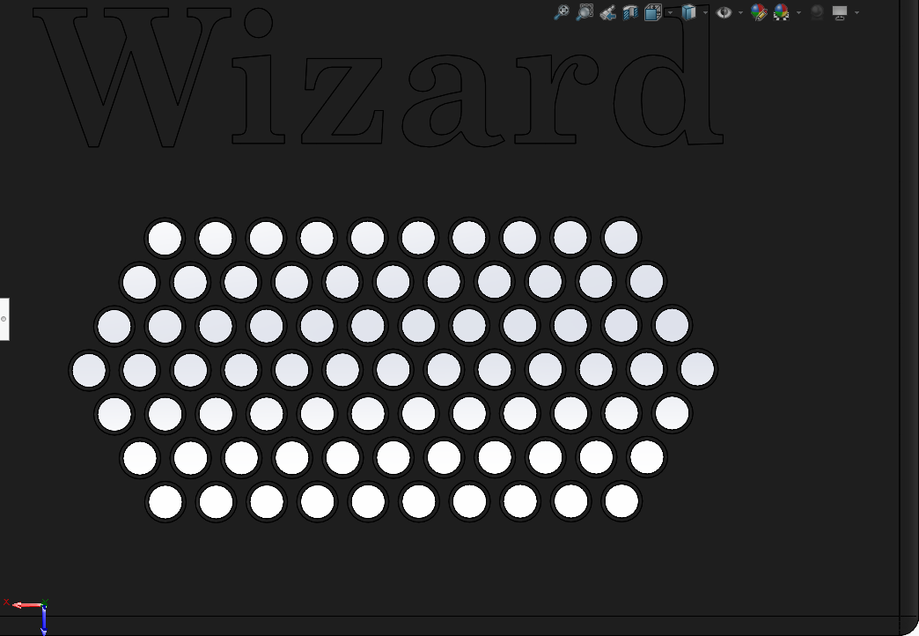 Figures 7-9: CAD renderings for varying speaker cover hole diameters (1.5mm, 2.5mm, 3.5mm)

Procedure:
- Gather all materials.
- Place materials on a table that is cleared and ready for the test.
- Hook up the speaker to the amplifier + microcontroller apparatus.
- Cover speaker with speaker cover
- Hold sound level reader at ear level
  - Speaker should be oriented towards you, still on the table
- Use the sound level reader to collect data from the speaker output.
- Output text to speech word from the speaker.
- Repeat steps 4 through 6, changing / adding the speaker cover of varying hole diameters.
- Write down results in the data table.
- Write down any observations collected during the test.

Quantitative Results:
Table 5: Table to collect effective decibels across three tests at different amounts of obstruction
Decibels  (dB) | Control  (no cover) | Hole Diameters (mm)
 |  | D1 | D2 | D3
Run 1
Run 2
Run 3
Average
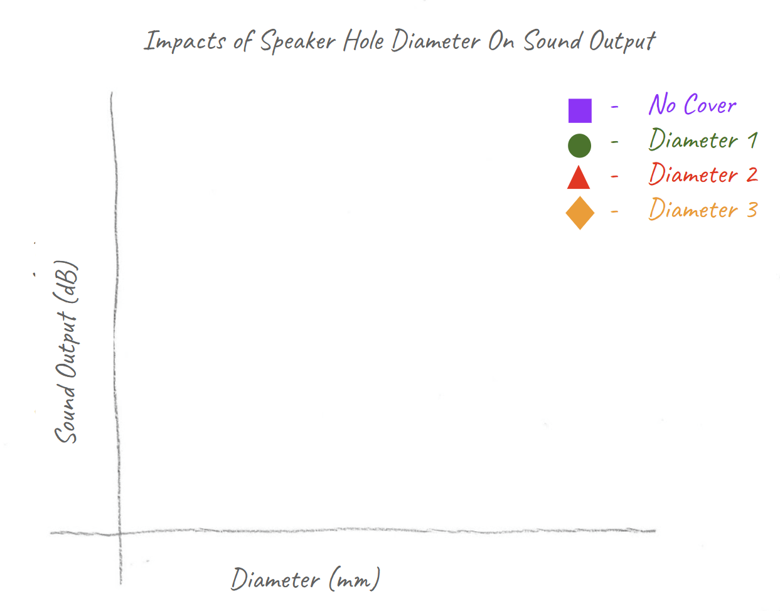
Figure 10: Scatterchart to compare effective decibels at different diameters of holes
Observations:
After conducting the experiment we have noted that the 2.5mm diameter speaker grill will give the best sound output. Along with the best sound output we observed that it will do better against keeping out dust and debris compared to its larger counterparts. The smaller diameters have too much of a sound loss to justify being better at keeping the dust and debris out.

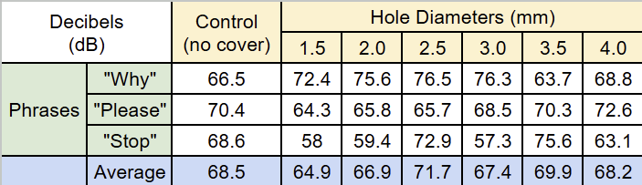
Table 6: Raw test result data displaying test words utilized
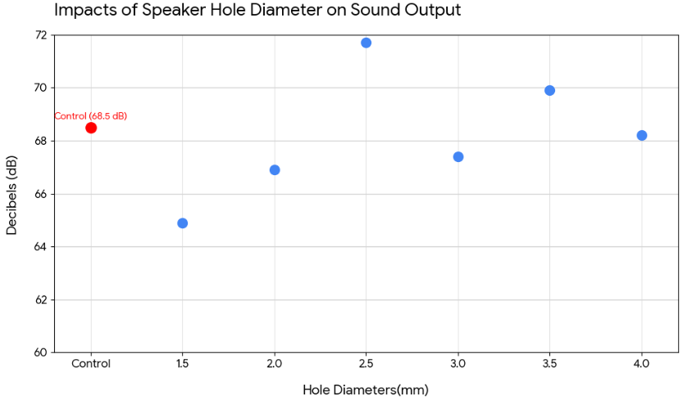
Figure 11: Plotted chart displaying decibels versus hole diameter data

Picture:
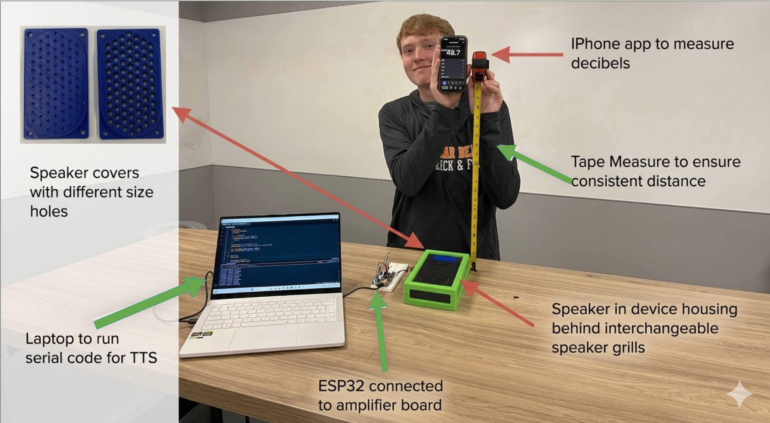
Conducted by: Ethan D’souza, Owen Willoby, Jeremiah Koenig, Aiden McManis

Date test conducted: 4/9/26

Appendix 3: Design Details
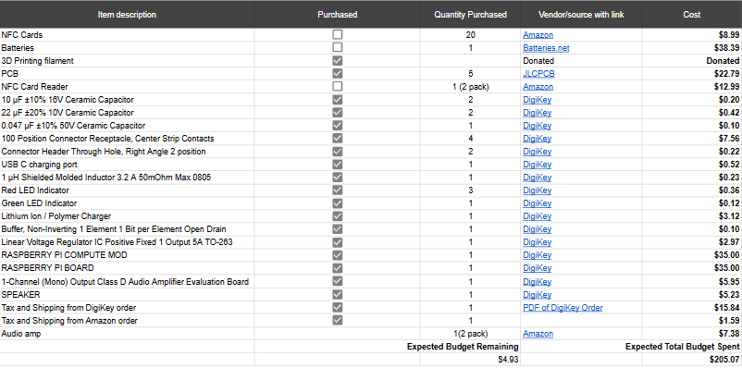
Appendix 4: Budget Tracker

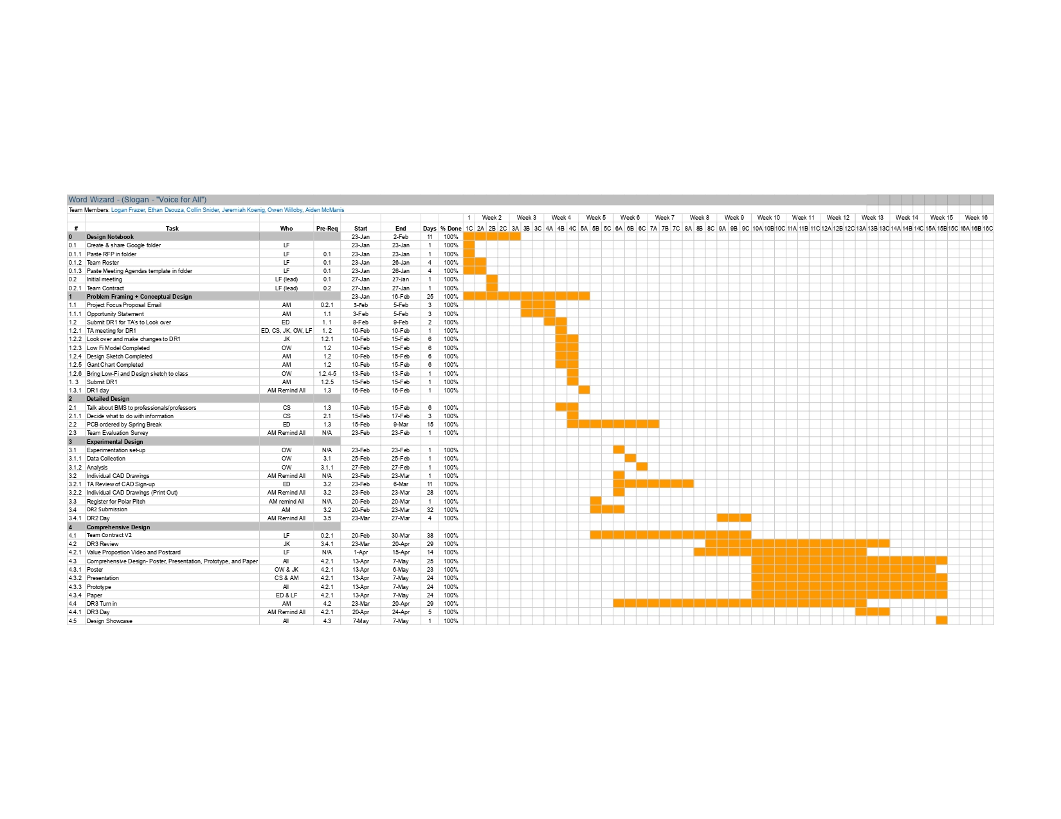
Appendix 5: Gantt Chart

Appendix 6: AI Disclosure
AI was used in problem framing, refining text, and programming the device. AI models used were Claude, Gemini, ChatGPT, and GPAI.

Appendix 7: Electronics Troubleshooting

Troubleshooting:

Unfortunately, but expectedly one of the most time consuming aspects of the project was attempting to diagnose an intermittent problem on the custom PCB. The code and hardware had previously been proven for functionality on a development board with jumpers, however upon transferring the compute module and components it began to encounter an error. For unknown reasons at the time, the board would function as expected on the surface level for about 20-30 seconds after boot up. However, when a card was introduced after this period it would lead to a boot cycle. The first diagnosing step taken was to isolate any potential power problems. Each board was given its own power supply and retested. Yet, the issue was not so simple. Next, the PN532 was hooked up to an oscilloscope to analyze its I2C data bus. See below.
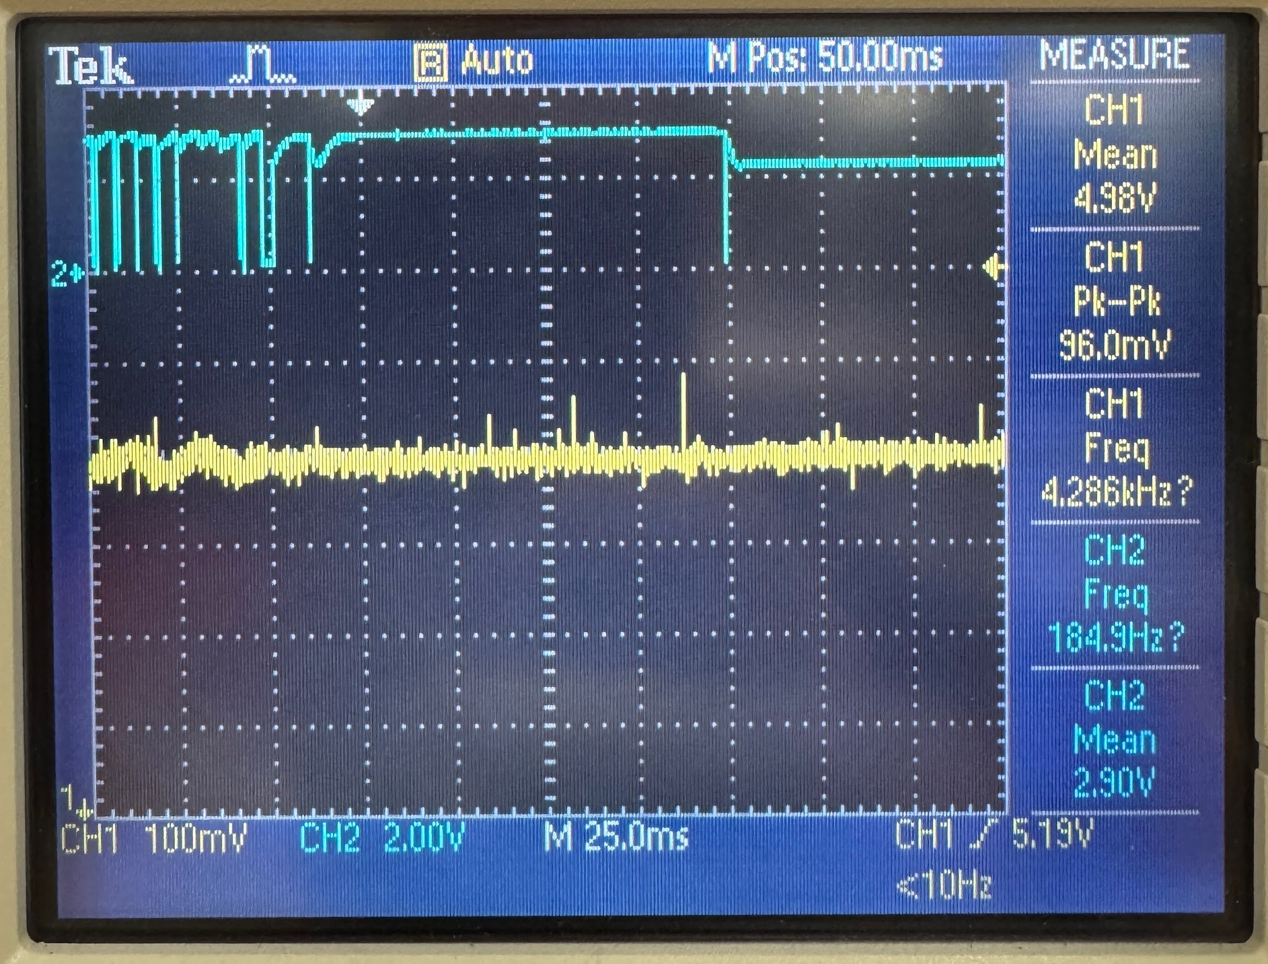

Figure 12: I2C communication, CH1 5V power, CH2 SDA
There are many details to note in this snapshot. First, we can note that the noise in the 5V rail is acceptable as it is well within the tolerance of ±5% or ±0.25V. Next, The I2C data line is not achieving full logic high of 3.3V. In the testing, it showed a maximum value of 3.1V. This is most concerning. It should be noted that there had been 2kΩ pull-up resistors to each I2C pin to achieve functionality. Since these pull-ups were in place, the logic high should always be 3.3V. In further reviewing of datasheets, these pull-ups were not necessary, as the board has internal 1.8kΩ pull-up resistors. However, the fact that the logic rail was not returning to 3.3V still suggested that something was ‘fighting’ the external pull up resistors. Our next hint comes from the failure mode of the I2C data pin. After about 20-30 seconds of abnormal operation, the data rail would return to 2.31V, once again despite the 3.3V pull-up resistors. This clearly shows that the board had detected some sort of fault and entered a fail-safe mode, powering down itself.
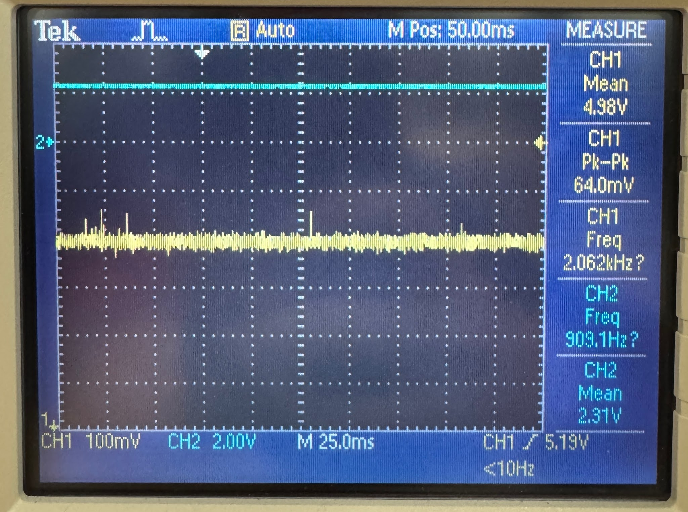

Figure 13: CM4 power shutoff, CH1 5V power, CH2 SDA
These specific fail cases led us to believe that something on the board was left ‘floating’ or not connected, as these issues did not occur with the exact same setup as the development board. After a complete review of development board schematics to ensure no circuitry was absent on the custom board, we went to review forums suggesting which pins left floating may cause such an issue. After much research, there were a few options to test, including enable or reset pins, however, GPIO_VREF turned out to be the pin that matched our exact symptoms. This input is the voltage reference which must be pulled directly to 1.8V or 3.3V to determine the logic level of the GPIO pins. Since it was left floating, it averaged to the mean between 0 and 5V, or approximately 2.3V. A simple overlook, and catastrophic consequences. This explains each problem we encountered, the external pull-ups, although enough to make the threshold of logic high, caused an extra thermal load in the GPIO controller, since 3.3V were ‘fighting’ the 2.5V reference. This explains how the board knew something was awry and reset itself by thermal protections, which realised about 20-30 seconds afterboot. The solution to this problem was to manually adjust the PCB traces and hardwire the voltage reference to 3.3V as it should have been designed.
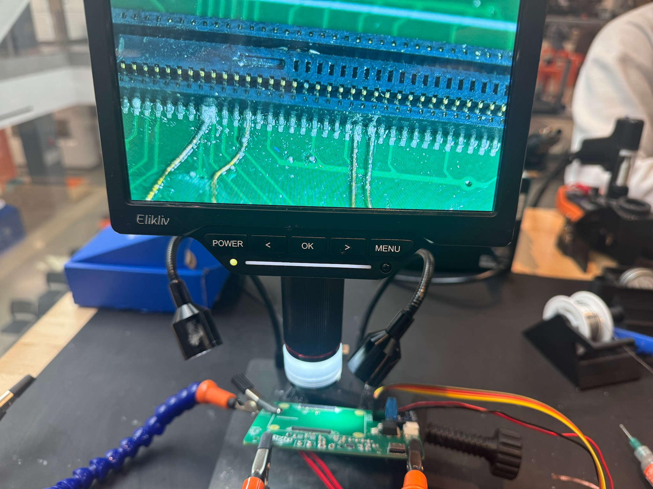
Figure 13: Manually adjusting PCB traces to Hirose connector
The above Figure 13, demonstrates the scale at which this repair had to be made, another previous adjustment can be seen. This was an attempt to rule out software errors, the I2C pins were swapped to ones that would match the development board to try to control as many variables as possible. On the next page, Figure 14, is a close up of the soldering process. Note that the wires pictured are 39 AWG or approximately 3 thousandths of an inch in diameter. A pair of 3.3V pins are leftmost, and the GPIO_ VREF is the adjacent solder connection. This process took a few hours alone to perfect. Too little or too much solder could lead to further complications.

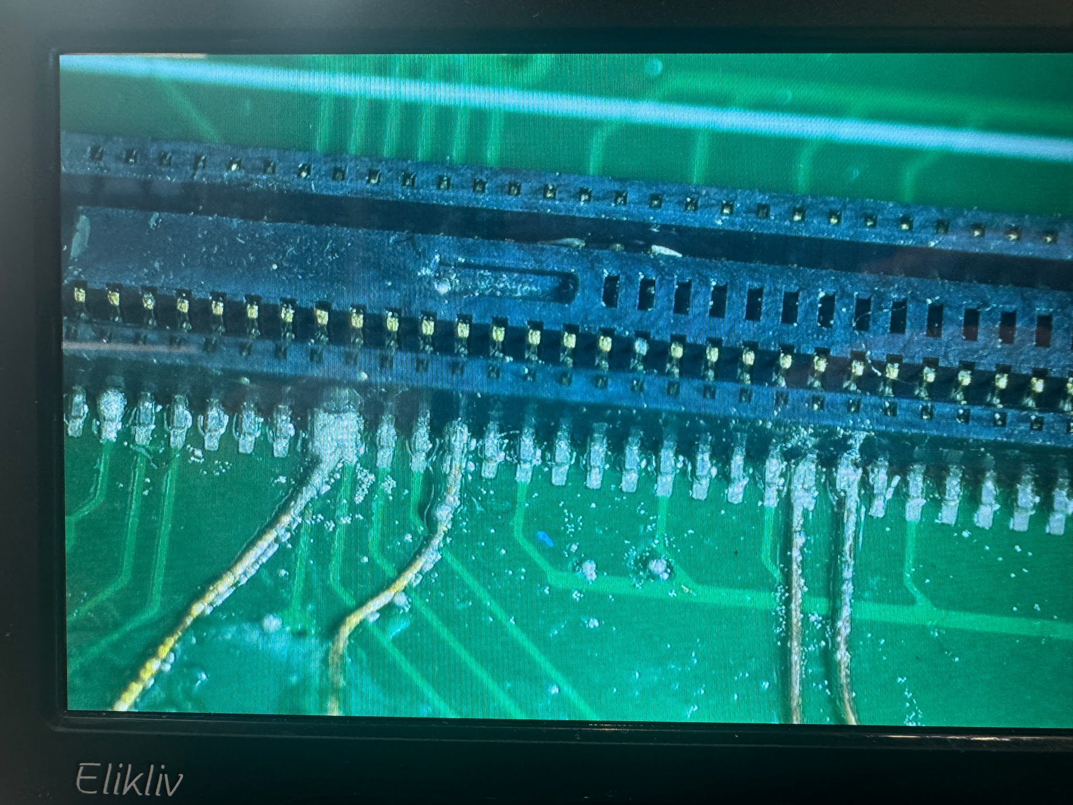Figure 14: Soldering microscope view
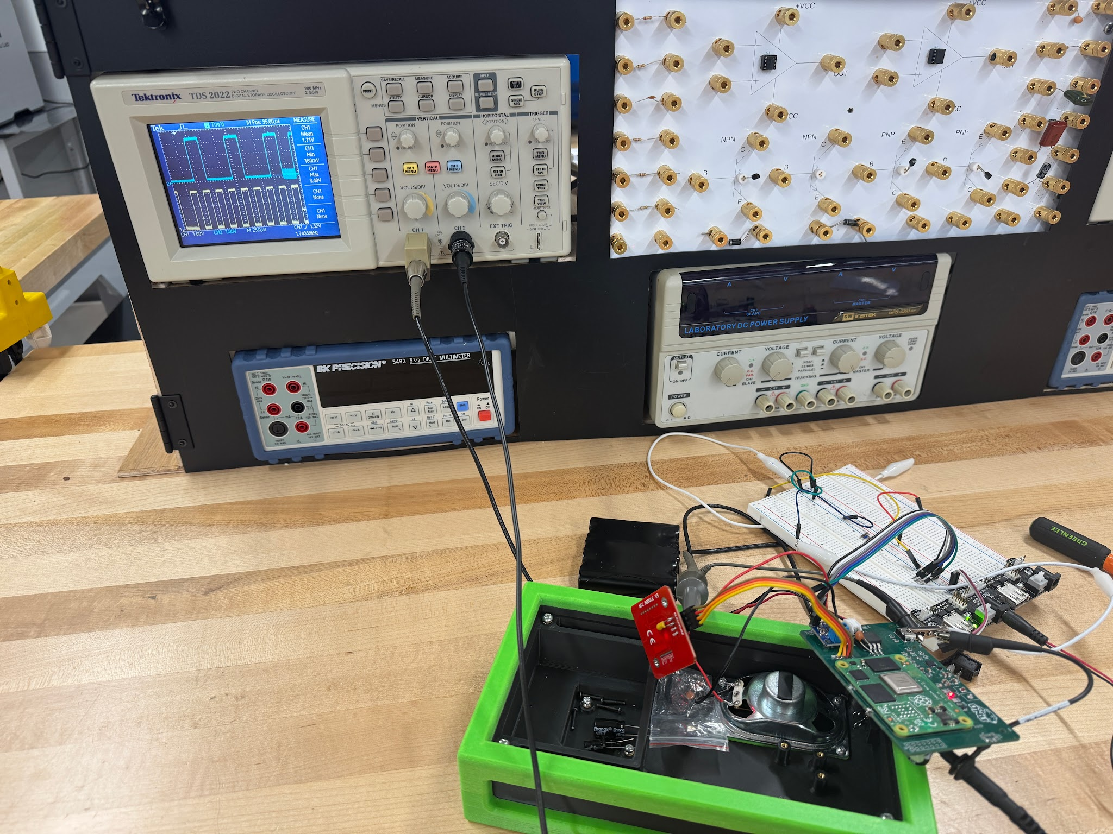
The Next step was to make it back to the oscilloscope to verify the fix. Figure 15 demonstrates the setup for this last test and Figure 16 is a detailed view of the oscilloscope.
Figure 15: Diagnosing workbench setup

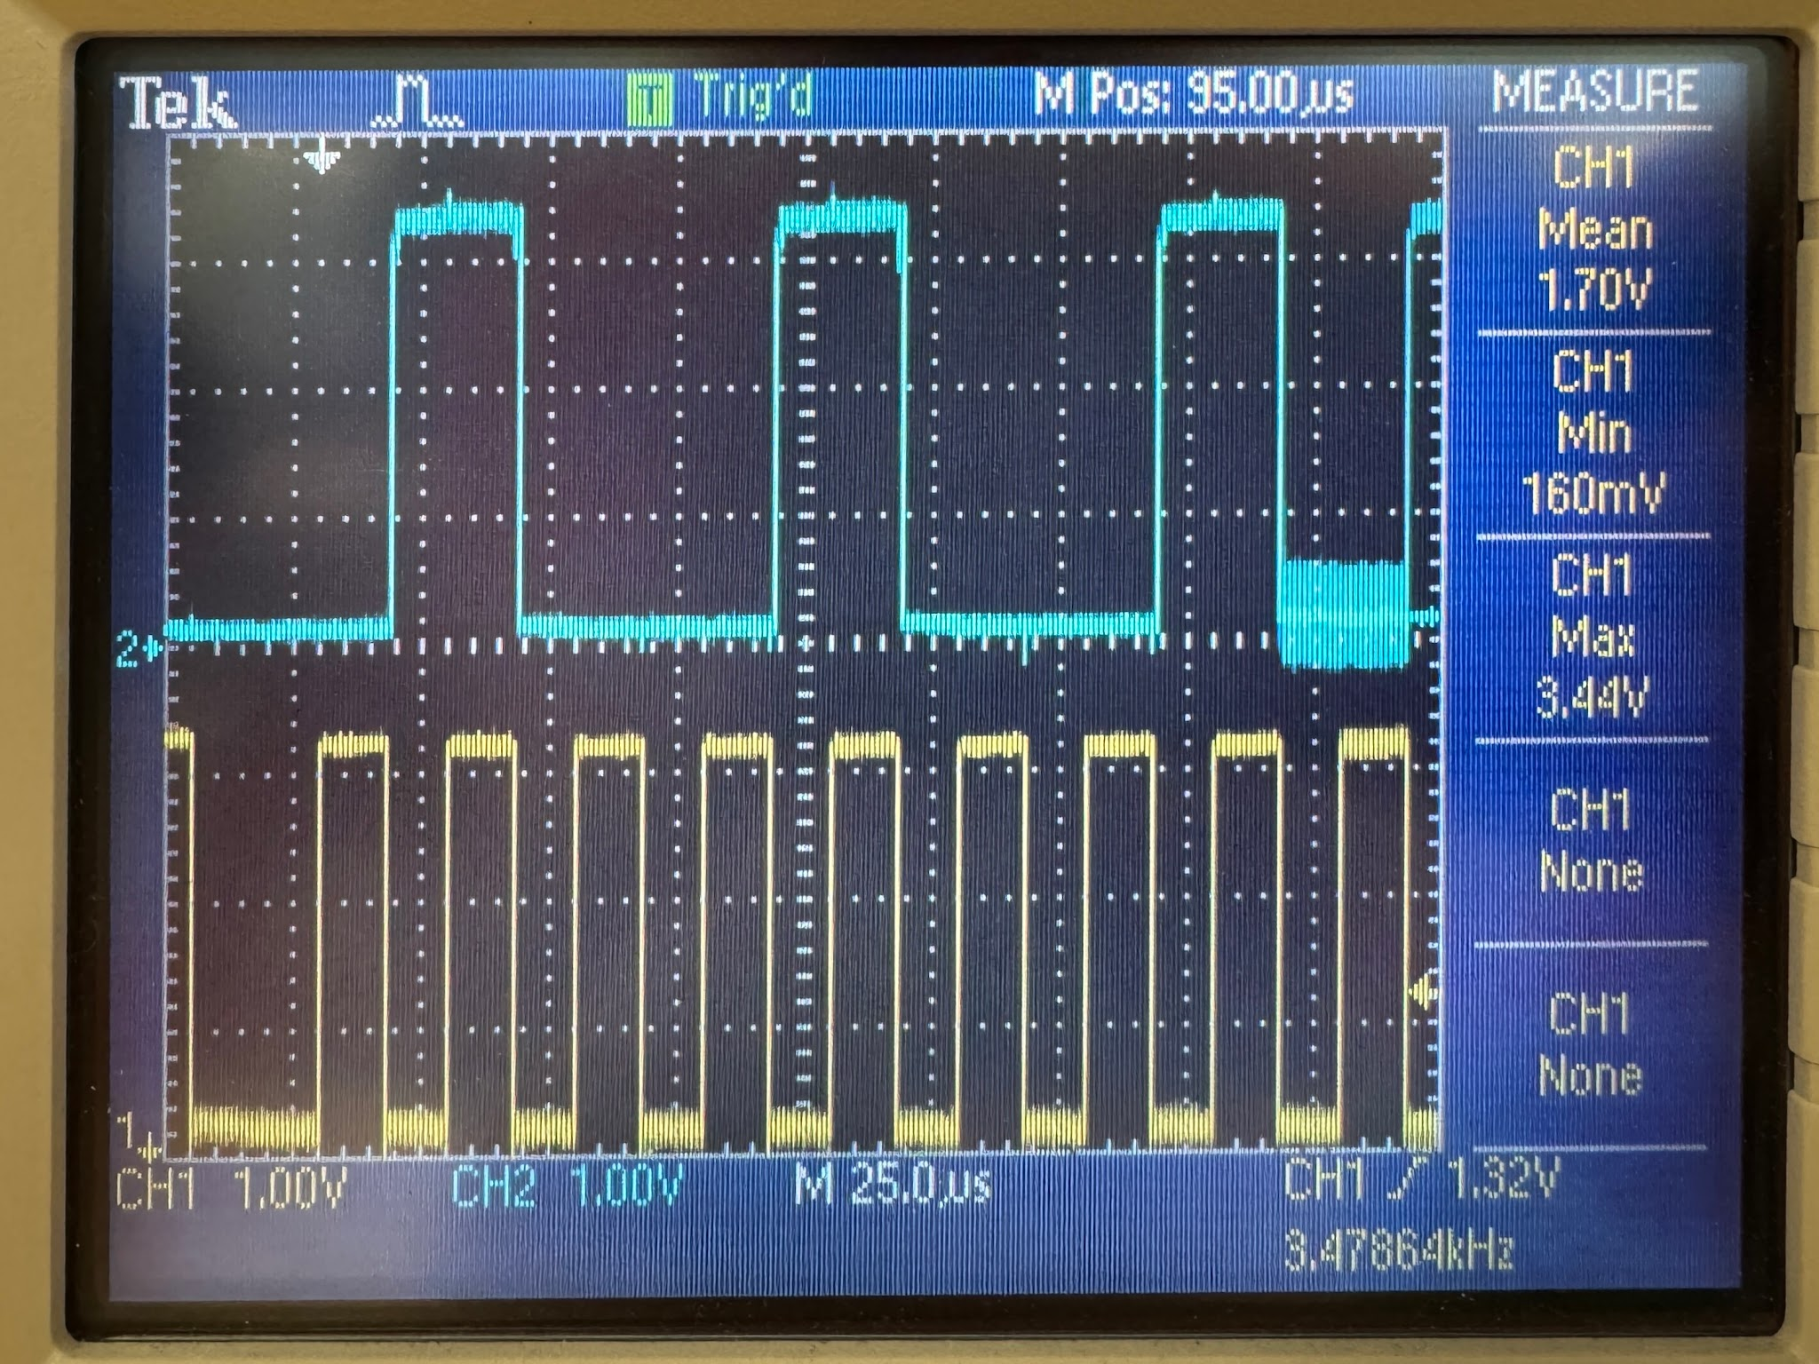

Figure 16: Fixed GPIO_VREF and digital communications. CH1 I2C SCL, CH2 I2C SDA
The results were exactly what we had hoped to see, clean rising and falling edges, well beyond the logic voltage thresholds. This overlook turned into a much harder to chase problem, however the lessons learned in the troubleshooting and diagnosing process are much greater than they would have been if everything had gone to plan. This problem turned out to be an invaluable teaching moment in both the art of measurement tools, soldering, but also emphasized the importance of checking, double checking, and peer reviewing designs whenever possible.

Appendix 8: User Manual

Appendix 9: Code

References
DR1

[1] “Classroom layout desk & table sizes.” Dimensions.com. https://www.dimensions.com/element/classroom-
layout-desk-table-sizes (accessed Feb. 12, 2026).
[2] BASF Corporation, Elastollan® – Properties: Chemical Properties. https://www.basf.com/dam/jcr:e42483e4-
4087-3544-a6a2-f958427c1030/Elastollan_Properties-Chemical-Properties.pdf (accessed Feb. 12, 2026).
[3] T. Boissonneault, “Vapor smoothing 3D printed parts.” Wevolver. https://www.wevolver.com/article/vapor-
smoothing-3d-printed-parts?utm_source=chatgpt.com (accessed Feb. 12, 2026).
[4] “Understanding different types of USB cables for mobile charging.” GP Batteries. https://uk.gpbatteries.com/
blogs/news/understanding-different-types-of-usb-cables-for-mobile-charging (accessed Feb. 12, 2026).
[5] S. Wickstrom, “PETG vs PLA vs ABS: 3D Printing Strength Comparison,” Ultimaker. [Online]. Available:
https://ultimaker.com/learn/petg-vs-pla-vs-abs-3d-printing-strength-comparison/. Accessed: Feb. 12, 2026.
[6] The Blind Life, “Making Voice Labels with NFC Tags”, YouTube video, 2025 (approx.). [Online]. Available:
https://www.youtube.com/watch?v=txDQfPz1oOw

DR2
[1] “Understanding different types of USB cables for mobile charging.” Gp Batteries. https://uk.gpbatteries.com/blogs/news/understanding-different-types-of-usb-cables-for-mobile-charging (accessed Feb. 12, 2026).
[2] American Speech-Language-Hearing Association, “Classroom Acoustics,” ASHA Practice Portal. [Online]. Available: https://www.asha.org/practice-portal/professional-issues/classroom-acoustics/
[Accessed: Mar. 22, 2026].
[3] S. Parker, “Storing PECS Pictures,” The Autism Helper. [Online]. Available: https://theautismhelper.com/storing-pecs-pictures/
[Accessed: Mar. 22, 2026].

DR3
[1] Y. Suzuki and T. Tanaka, "Vibration and acoustic analysis for the speaker cover," J. Technol. Soc. Sci., vol. 6, no. 2, pp. 112–125, 2022.
[2] E. Fitzgerald, Straight Language for the Deaf: A System of Instruction for Deaf Children, 2nd ed. Washington, DC, USA: The Volta Bureau, 1926.
[3] S. C. Wu, C. L. Lin, and C. Y. Chen, "Effects of color-coded designs on cognitive load and learning performance: An eye-tracking and EEG study," Front. Psychol., vol. 12, art. 642013, Jun. 2021, doi: 10.3389/fpsyg.2021.642013.

Individual Contributions
Table 7: Individual contributions
Name | Contributions | Hours since DR3
Ethan D’Souza | - created opportunity statement and key design features collage in final paper  - took photos for final paper  - Wrote Next Steps paragraph in final paper  - Formatted and edited problem framing documentation throughout semester and formatted in final paper  - updated and formatted testplan in final paper  - updated and formatted references section in final paper  - Completed Eco-Design Strategies paragraph for final paper  - Completed Broader Impacts section for final paper  - researched and completed benefits and risks/tradeoffs  - Completed formatting and cleanliness of final paper  - contributed to revision of Poster and completed electronics selection | 6
Logan Frazer | - Helped with poster content and formatting  - Helped with paper content and formatting  - Programmed NFC cards with final word set  - Updated and finalized CAD drawings  - Updated figures 1-5  - Annotated main case assembly drawing | 6
Aiden McManis | - Helped with Poster with organization, and to make sure everything looked good  - Gantt Chart put into doc  - Helped with presentation for Design Showcase | 4
Owen Willoby | - Created the Poster and worked to finalize it  - Kept and organized all receipts and finalized the budget  - Helped with presentation for design showcase  - Helped troubleshoot product and fix product  - Helped with paper content and formatting | 5
Jeremiah Koenig | - Helped finish product (clean up all parts, put final components on PCB, assemble final product)  - Helped touch up poster  - Helped work on presentation | 10
Collin Snider | - PCB diagnosing and repair  - Install new board  - Helped with poster design  - Helped with final paper  - Helped to assemble and clean up wiring of electronics in the final product | 25

